[**Middle of the Linked List**](https://leetcode.com/problems/middle-of-the-linked-list/)

**Task1**

**Code**

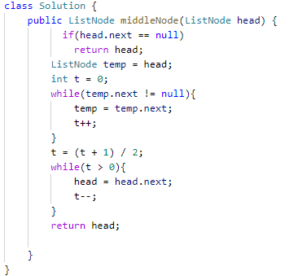

**Output**

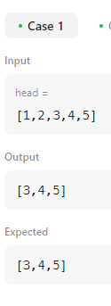

[**Convert Binary Number in a Linked List to Integer**](https://leetcode.com/problems/convert-binary-number-in-a-linked-list-to-integer/)

**Task 2**

**Code**

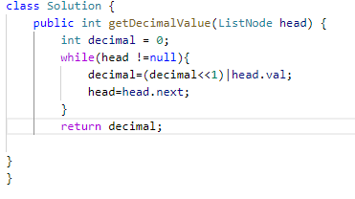

**Output**

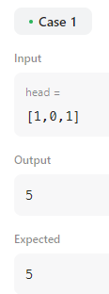

[**2. Add Two Numbers**](https://leetcode.com/problems/add-two-numbers/)

You are given two **non-empty** linked lists representing two non-negative integers. The digits are stored in **reverse order**, and each of their nodes contains a single digit. Add the two numbers and return the sum as a linked list.

**Task 3**

**Code**

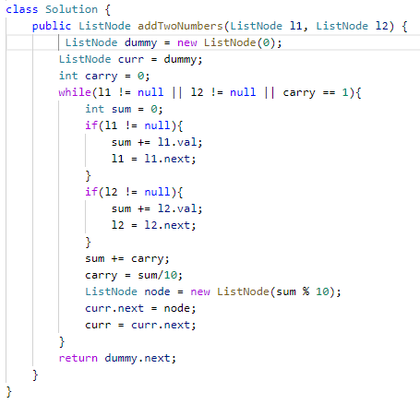

**Output**

